Birla Institute of Technology & Science, Pilani
Work-Integrated Learning Programmes Division
First Semester 2022-2023

Mid-Semester Test
(EC-2 Regular)

Course No. : SE ZG587
Course Title : Open Source Software Engineering
Nature of Exam : Open Book
Weightage : 30%
No. of Pages = 1

No. of Questions = 4
Duration : 2 Hours
Date of Exam : Friday, 23/09/2022 (FN)
Note:
- Please follow all the Instructions to Candidates given on the cover page of the answer book.
- All parts of a question should be answered consecutively. Each answer should start from a fresh page.
- Assumptions made if any, should be stated clearly at the beginning of your answer.

- Please draw a comparative between Freeware, shareware, open source, proprietary and public domain software. Marks [5]

Ans:

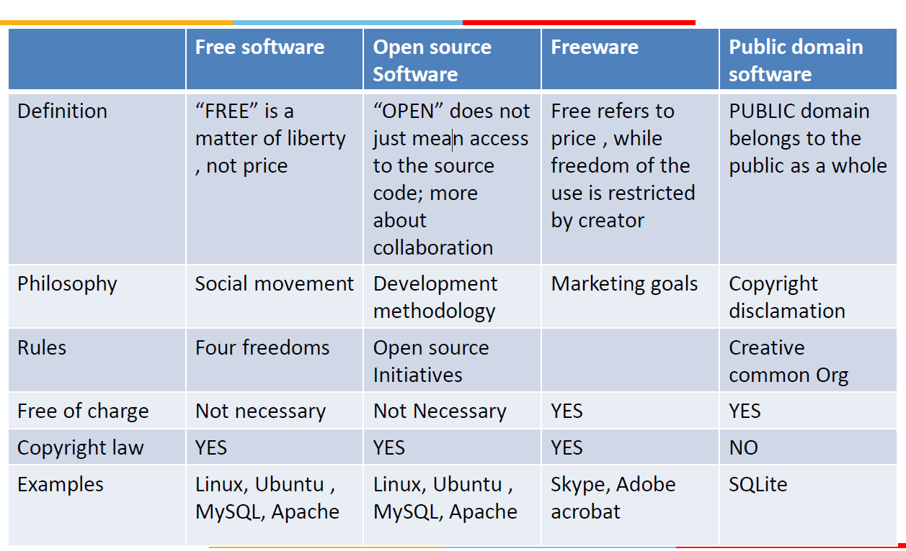

Shareware software is a software that are freely distributed to users on trial basis. There is a time limit inbuilt in the software( for example- free for 30 days or 2 months). As the time limit gets over, it will be deactivated. To use it after time limit, you have to pay for the software.
Users prefer shareware because of following reasons –

Available free of cost
helps to know about the product before buying it
Some examples of freeware software are –

Adobe acrobat 8 professional
PHP Debugger 2.1.3.3
Winzip
Getright
Shareware are of following types:

Adware – Contains ads to generate revenue for the developers
Donationware – payment is optional
Nagware – reminds user to purchase the license or the software
Freemium – free for non-premium but of cost for premium features
Demoware – demonstration version. It is further classified as crippleware and trialware.
Crippleware – Some features are disabled under time-limit
Trialware – all features are available under time-limit

- What issues someone may face if a so-called open-source product doesn’t have a license? What actions would you perform to distribute your OSS product? Marks [3 + 5]

Ans:

To use or contribute to project that has no license associated with it
•Do not use the software : Find or create an alternative that is
under an open source license
•Request the Project Maintainers to add a license :
•Unless the software included strong indications to the
contrary, lack of a license is probably an oversight.
•If the software is hosted on a site like GitHub, open an
issue requesting a license
•If you are sure what license is most appropriate, open a
pull request to add a license with a suggestive license

- How can someone earn revenue from an OSS product? What are the differences between copyright and copyleft? Marks [5 + 2]

Copyright is a legal term that gives creators the rights to control the use and distribution of their work. Copyright protects authors from unauthorized copying or selling of their work.
Copyleft is a method that allows copyrighted work to be modified and distributed back to the community. Copyleft licenses give users the same rights as the original author, including the freedom to use, study, and copy the work. However, copyleft licenses require users to distribute unoriginal w

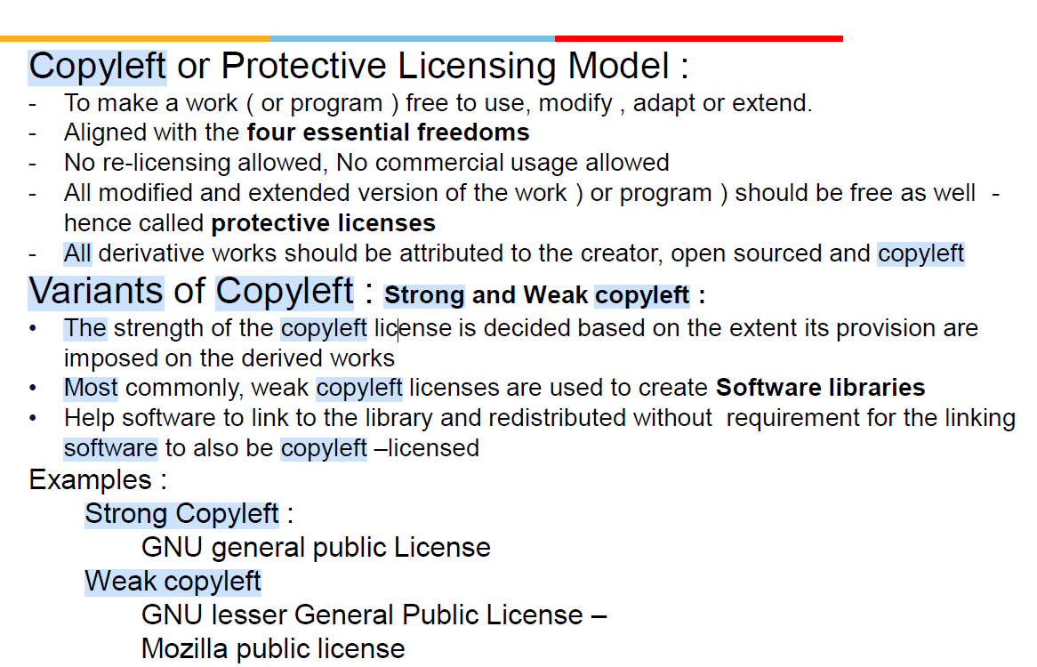

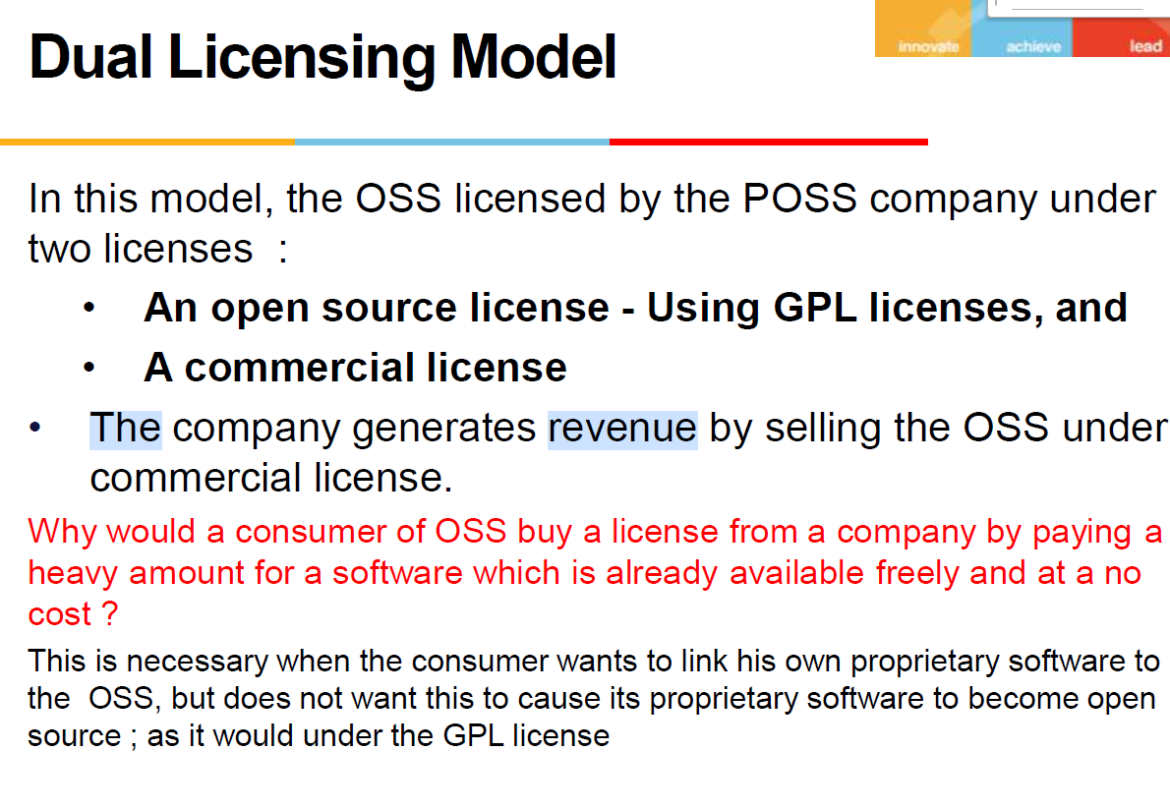

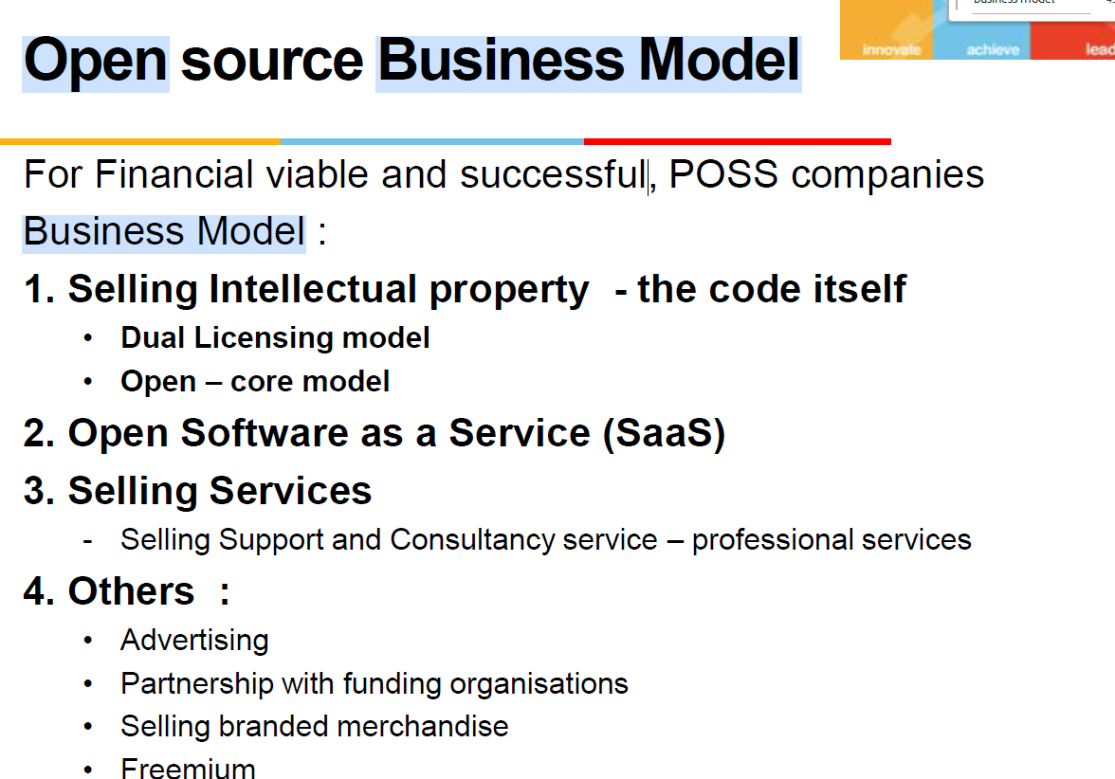

- How would you form your own OSS development forum and what strategies would you like to implement to come out with a successful venture?
How is OSS development different with regards to corporate development? Marks [6 + 4]

Ans:
Open source development is the practice of creating and sharing software code in a collaborative way. Here are some tips for creating a successful open source project:
Come up with the right idea.
Create a project page on a website like Github, Sourceforge, or Google Code Hosting.
Create a “code of conduct” before you begin.
Once you get started, never stop.
To develop a successful open source development strategy, it is important to have a deep understanding of your domain. This means knowing the technologies, methodologies, and practices relevant to your industry. It can take time to grow your domain expertise, so it is essential to be patient and persistent.
To contribute to an open source project, you can:
Join the project's communication channels, such as mailing lists, forums, or chat platforms.
Ask questions, seek guidance, and discuss your ideas before making significant contributions.

*******

